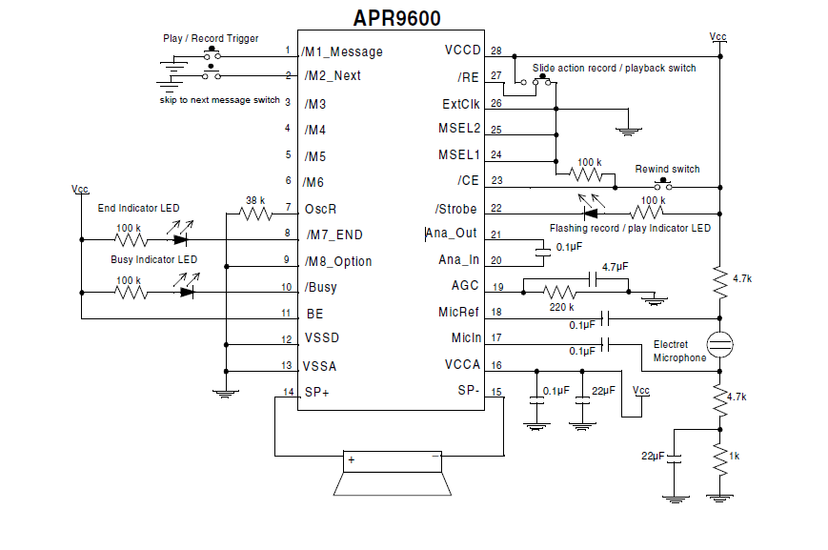
APR9600:
Single-Chip Voice Recording & Playback Device
60-Second Duration

